**SQL Roadmap**

Pre-Requisites:

-- First thing to understand is SQL is a programming language that is used to interact with relational database.

-- If you are building an application/software, your application will need data. This data is generally not stored in the application, in most of the cases it is stored in the database.

-- So, your application needs a way to interact with relational database in order to use your data.

-- And relational database only understands one language – SQL.

-- There are several types of relational databases:

> Oracle

> MySQL

> PostgreSQL

> Microsoft SQL Server

-- Also, there are several cloud-based databases and data warehouses:

> Google BigQuery

> Amazon Redshift

> Snowflake

-- Now it does not matter which database you choose in order to learn SQL. Because 80-90% of the SQL used in all of these RDBMS are same. So, whatever you learn from one RDBMS, you can apply it any other RDBMS. There could be differences in certain in-built functions which might be supported in one RDBMS, and not in other. But you will find an alternative function which does the same thing.

-- First thing to do in order to start with SQL learning is to install the database on your system.

-- Second thing to do is to install an IDE tool in order to connect with the database and play around using queries.

|  |  |
| --- | --- |
| Database | IDE |
| PostgreSQL | PgAdmin |
| MySQL | MySQL Workbench |
| Microsoft SQL Server | SQL Server Management Studio |
| Oracle | SQL Developer |

Basic SQL

1. What is a Relational database/RDBMS?

> How data is stored in RDBMS?

> What is a schema w.r.t. to a relational database?

2. SQL Commands

> DDL, DML, DCL, TCL, DQL

> What are the commands under each of these categories and

What each of these commands do?

3. Data Types

> String datatype like VARCHAR, TEXT etc

> Integer data type like INT, NUMBER etc

> DATE

> FLOAT/DECIMAL

> BOOLEAN (if supported)

> Identity column (Auto increment column)

4. Constraints

> Primary key

> Foreign key

> Check, not null, Unique, Default etc

5. Normalization in SQL

> Different normal forms like 1NF, 2NF, 3NF, BCNF.

6. Operators

> Arithmetic operator

> Logical operator

> Comparison operator

> UNION, UNION ALL operator

7. CASE statement

> Simple as well as nested case statement

8. Important SQL clause

> DISTINCT clause

> Order by clause

> LIMIT/TOP clause

9. Inner Join

> How do you fetch data from multiple tables?

Intermediate SQL

(Data Analyst, Data Scientist)

1. Group by and Having clause

2. Aggregate Functions

> Min, Max, Avg, Sum, Count

3. Order of Execution

4. Sub-queries

5. CTE table/With clause

6. All Types Of Joins

> LEFT, RIGHT, FULL OUTER

> Cross Join, Self Join

7. In Built Functions

> String functions like Substring, position, Coalesce etc

> Data functions like Extract, To_Date etc

8. Window Functions

> Most important are RANK, DENSE_RANK, ROW_NUMBER,

LEAD, LAG

> Good to have FIRST_VALUE, LAST_VALUE, NTH_VALUE, NTILE

9. Views

Advanced SQL

(Data Engineer, ETL Developer)

1. Recursive SQL Queries

2. PIVOT table/CROSSTAB function

3. Materialized View

4. Stored Procedures

5. User Defined Functions

SQL For Database

(SQL Developer, Database Developer)

1. Indexes

2. Triggers

3. Temporary Table

4. Dynamic execution of SQL statements

5. PL/SQL Concept

> Variables

> Cursors

> Collection type

> Loop statements

> If Else statements

> Exception Handling

> Packages

6. Performance Tuning

> Explain plan

> Table Statistics

> Table Partitioning

> DBMS_Profiler

> SQL Trace and TKProf

**PostgreSQL Installation**

-- Go to postgresql.org

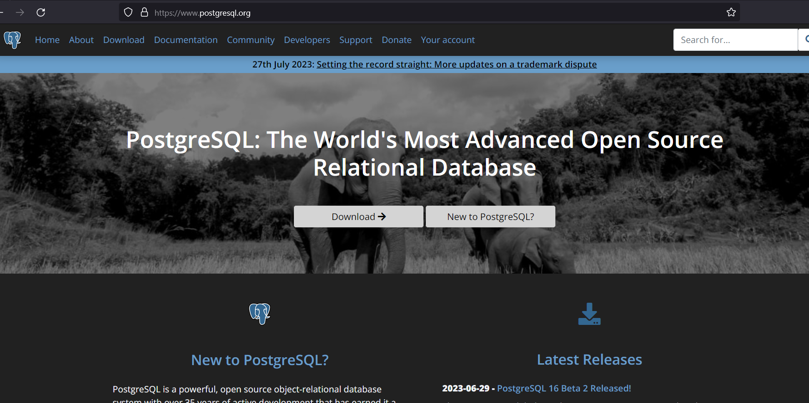

-- Click on Download.

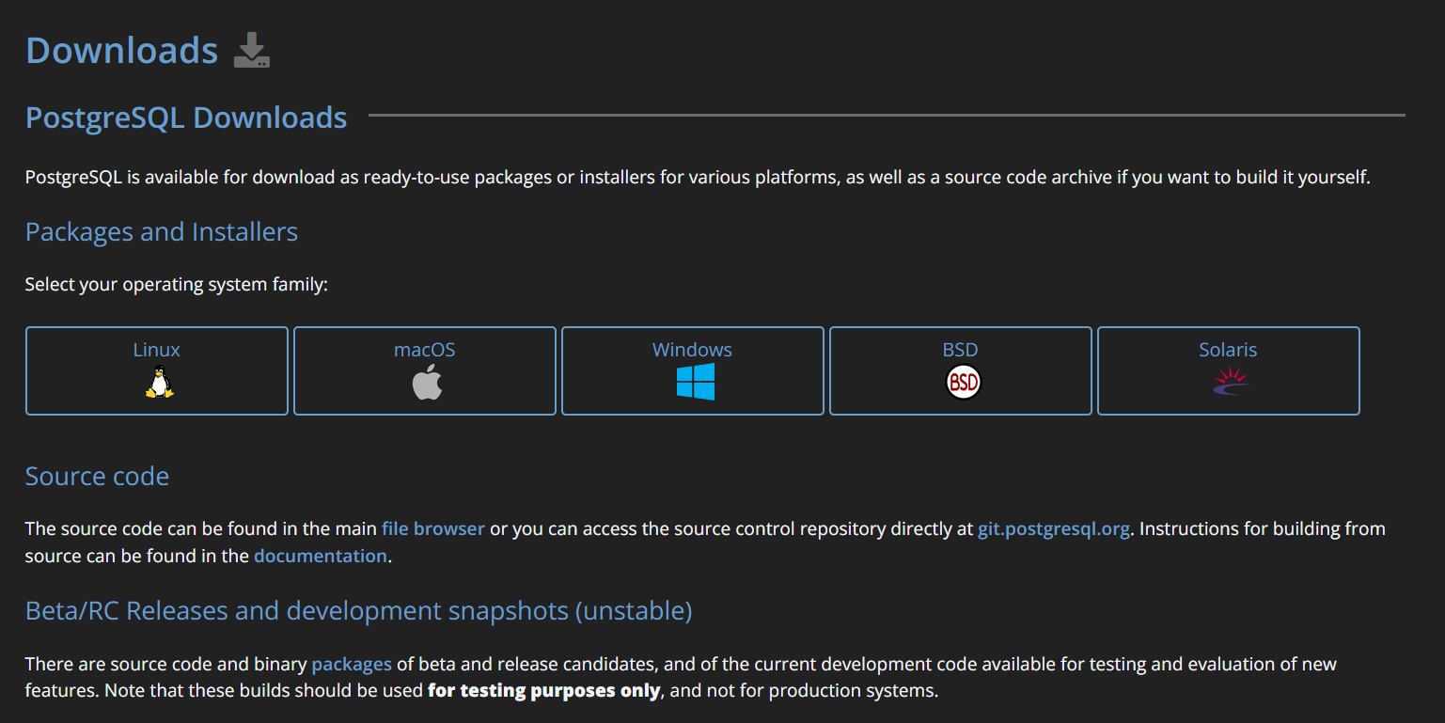

-- Select Windows as OS.

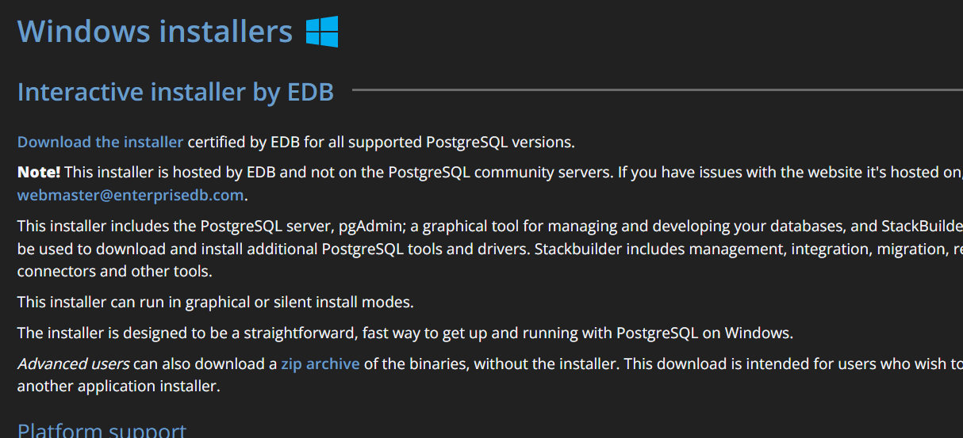

-- Click on Download the installer. And download the 15.3 version.

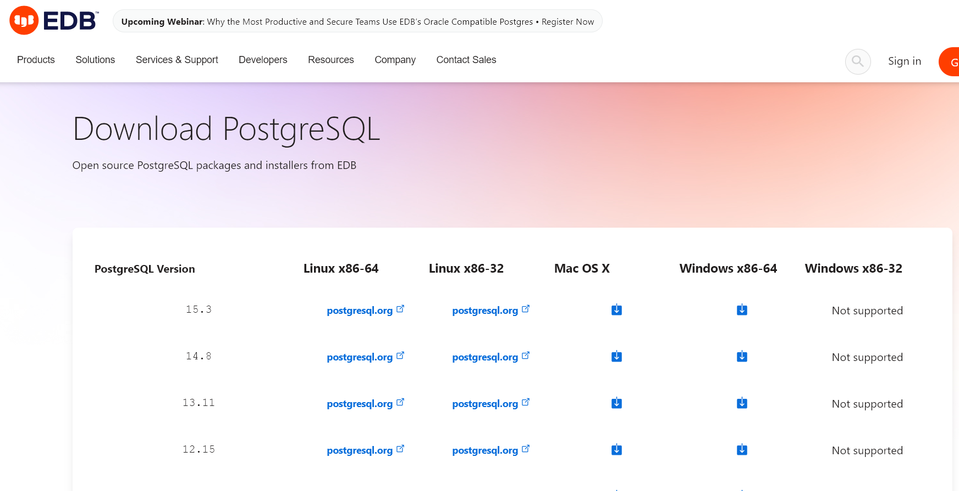

-- Double click on the downloaded exe file.

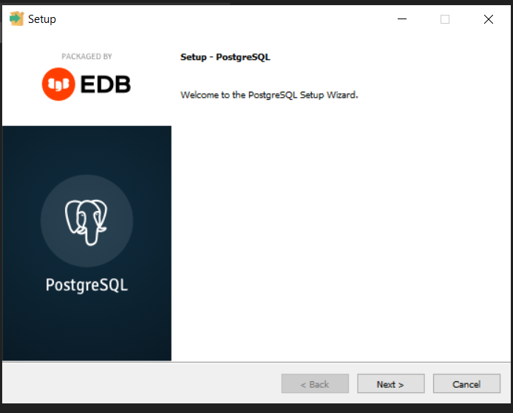

-- Click on Next. Select all the components.

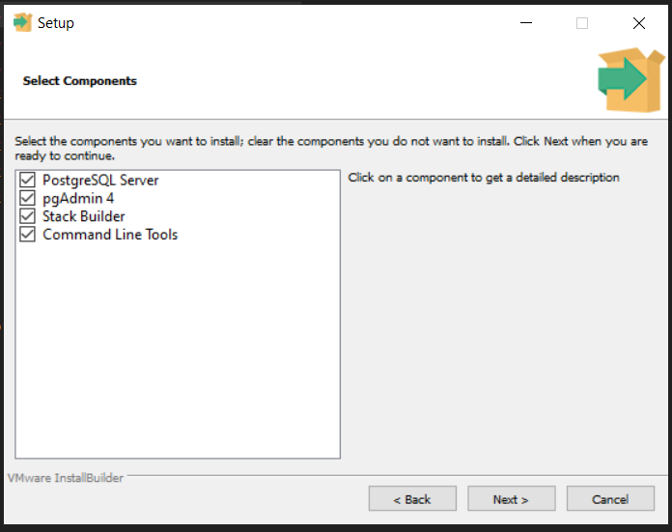

-- Enter the password and remember it well. (Rachit@123#)

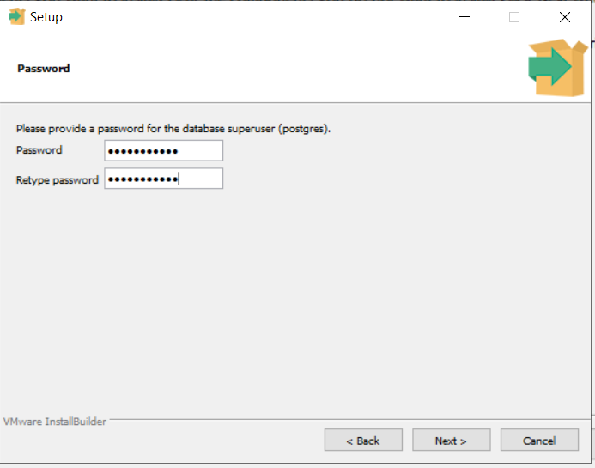

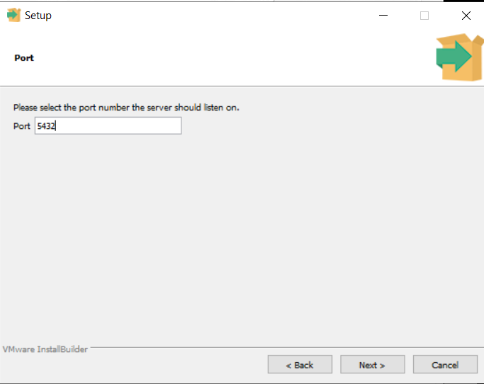

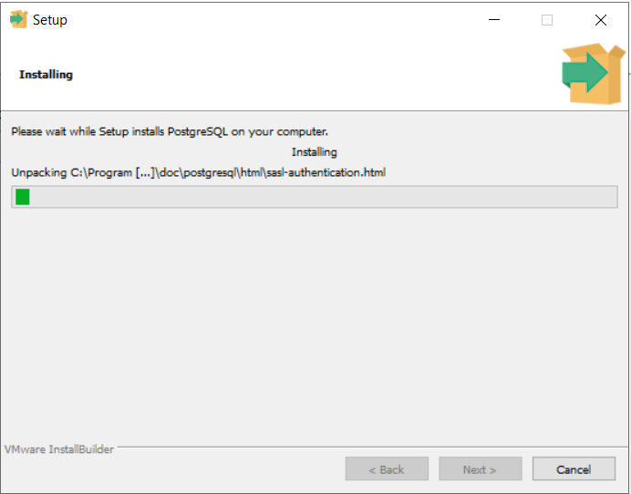

-- After installation, open the PgAdmin. Enter the password.

